HOLIDAY HOMEWORK
Leggi il brano e fai gli esercizi
MARTIN’S HOLIDAY
Martin had a terrible day yesterday. It was the day of his holiday to Spain but it was a nightmare. He left the house at 10 o'clock in the morning and caught a taxi to the airport.
Martin went to the check-in with his luggage. When the man who worked for the airline asked for his passport, Martin became very upset. Where was his passport? Martin realized he didn't have his passport with him. What a disaster!
He got back into the taxi and told the driver to take him home. The driver drove quickly and Martin arrived back at his house in twenty minutes.
He ran into the house and went into his bedroom. He found his passport on the bedside table and left the house again. But the taxi wasn't there! Where was the taxi?
Martin jumped up and down angrily. "I don't believe it. The taxi left!" he shouted. He ran down the street and looked for another taxi.
After a few minutes, Martin found another taxi and told the driver to take him to the airport as quickly as possible. The traffic on the roads was very bad and, unfortunately, Martin's taxi arrived at the airport late. His plane left for Spain at 11.30 and Martin missed it. He was very sad and went to speak to the airline information desk. They promised to get him a seat on an evening flight and Martin went home on another taxi, where he waited for the evening flight!

Inserisci I nomi sotto le figure:
nightmare – luggage – upset –passport – bedside table – evening flight
shout - taxi driver – airline information desk – plane seat
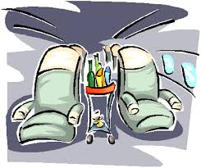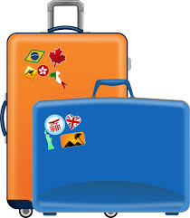
_______________ ___________ ____________ _______________ ______________

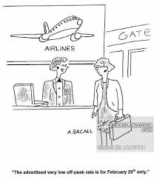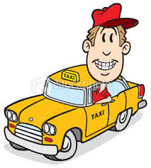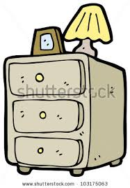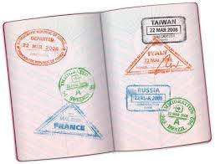
______________ _______________ _____________ ____________ ________________
Completa la tabella:
PRESENT | PAST | SIGNIFICATO
HAVE
BE
WANT
LEAVE
CATCH
GO
WORK
ASK
BECOME
REALIZE
JUMP
GET IN
TELL
TAKE
DRIVE
ARRIVE
RUN
FIND
JUMP
SHOUT
BELIEVE
LOOK FOR
MISS
SPEAK
PROMISE
WAIT
TRAVEL

Rispondi alle domande:
- WHERE DID MARTIN WANT TO GO ON HOLIDAY?
- WHAT TIME DID HE LEAVE THE HOUSE?
- HOW DID HE TRAVEL TO THE AIRPORT?
- WHY DID MARTIN BECOME VERY UPSET?
- DID MARTIN ARRIVE AT HIS HOUSE VERY QUICKLY?
- WHERE WAS THE PASSPORT?
- DID THE TAXI DRIVER WAIT FOR MARTIN?
- WAS MARTIN ANGRY?
- DID MARTIN FIND ANOTHER TAXI?
- WHEN MARTIN ARRIVED AT THE AIRPORT, DID HE TAKE THE PLANE TO SPAIN?
- WHAT DID THE AIRLINE PROMISE MARTIN?
Trasforma le frasi da presente a passato:
- He is angry ____________________________
- He finds another taxi ___________________________
- He leaves the house _________________________________
- He waits for Martin ___________________________________
Metti le frasi in forma negativa:
- He travelled by car ________________________________
- It was in his car ____________________________________
- He wanted to go on holiday __________________________________
- He arrived at the airport ______________________________________
Formula le domande per le seguenti risposte:
- ___________________________________________________?
They left at 12.30
- __________________________________________________?
They travelled by car
- ___________________________________________________?
The passport was in his pocket
- ___________________________________________________?
They promised to get him a new ticket.

